
Dunkin’ Brand Comprehensive case analysis
Albany State University MGMT 6199

November 27, 2019
Lanina howard

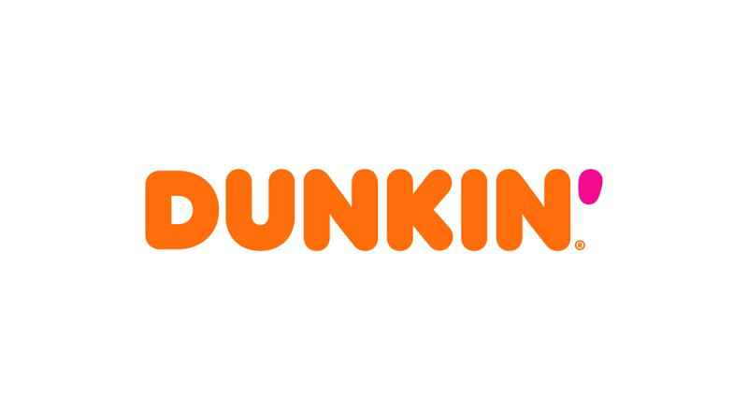

Dunkin’ Brands Comprehensive Case Analysis
Lanina Howard
Albany State University
November 27, 2019

Table of Content
Introduction……………………………………………………………………………………….4
- Founding of the Organization…………………………………………………………….4
- Trading Option for the Company…………………………………………………………4
- Top Executives at the Firm……………………………………………………………….5
- Business Model…………………………………………………………………………...7
- Influence of Global Markets……………………………………………………………...8
- Additional Information……………………………………………………………….......9
- Identification of the Industry and the Competitors………………………………………9
Industry Analysis……………………………………………………………………………......10
- Strategic Affiliations ……………………………………………………………………10
- Rivalry with competitors………………………………………………………………...10
- Potential Profitability of the Industry…………………………………………………....11
- Critical Success Factors…………………………………………………………………12
Analysis of the Macro-Environment…………………………………………………………….13
- Political and Legal Influences…………………………………………………………...13
- Economic Influences…………………………………………………………………….14
- Social Influences………………………………………………………………………...14
- Technological Influences………………………………………………………………..15
- Threats and Opportunities Facing Dukin’ Brands………………………………………15
Measurement and Control System……………………………………………………………...16
- Current Financial Position ……………………………………………………………..16
- Competitor Analysis……………………………………………………………………17
- Key Performance Indicators………………………………………………………….18
Analysis of the Organization…………………………………………………………………19
- Mission Statement……………………………………………………………………19
- Vision Statement …………………………………………………………………….19
- Core Values and Operating Guidelines………………………………………………20
- Uniqueness of Core Competencies in the Industry…………………………………..20
- SMART Approach to the Goals of the Organization………………………………...21
Future of Organization……………………………………………………………………….22
Conclusion…………………………………………………………………………………...22
Sources………………………………………………………………………………………24

Introduction
- Founding of the Organization
Independently in the 1940s, Bill Rosenberg founded the first Dunkin’ Donut restaurant, and Burt Baskin and Irv Robbins each founded a chain of ice cream shops that eventually combined to form Baskin-Robbins. Baskin-Robbins and Dunkin’ Donuts were acquired by Allied Domecq in 1973 and 1989, respectively, and renamed Dunkin’ Brands, Inc. in 2004. Allied was acquired in 2005 by Pernod Ricard, who soon sold the firm to Bain Capital Partners, LLC, The Carlyle Group, and Thomas H. Lee Partners, L.P. Bill Rosenberg opened his first donut restaurant, Kettle Donuts, in 1948, in Quincy, Massachusetts. The name changed to Dunkin’ Donuts in 1950. Rosenberg sold franchisees to others as early as 1955. The 100th restaurant opened in 1963, the 1,000th in 1979, and the 3,000th in 1992. In 1996, bagels were introduced to the Dunkin’ Donuts menu and breakfast sandwiches the following year.
In 1945, brothers-in-law Burt Baskin and Irv Robbins owned different ice cream parlors, Burton’s Ice Cream and Snowbird Ice Cream, both in Glendale, California. The separate companies merged in 1953 and the number of ice cream flavors increased to 31. That year, Baskin-Robbins hired Carson-Roberts Advertising who recommended adoption of the number 31 as well as the pink (cherry) and brown (chocolate) polka dots and typeface. In the 1970s, the company went international, opening stores in Japan, Saudi Arabia, Korea, and Australia. Baskin-Robbins was the first company to introduce ice cream cakes to the public, and the first to offer both hand scooped and Soft Serve ice cream. In some places, such as Malaysia, Baskin-Robbins gives 31 percent off their hand-packed ice cream on the 31st of a month.
- Trading option for the Company
Acknowledgement as a public company allows the corporation to sell the shares it has registered to the general public. The trading of the stocks of such corporations is accomplished in stock exchange. A private company has privately held shares, to which the sell to a chosen few investors. Those chosen few own and trade in the stocks. In 2011, Dunkin’ Brands became listed on the NASDAQ Global Select Market under the symbol “DNKN.” The shares for the brand are publicly traded. Therefore, the brand is publicly held.
- Top executives at the firm
The brand does not have two separate posting for Chief Executive Officer and President, and David Hoffmann currently fills in for both positions. He earned a B.S. in accounting From Indiana University, and an MBA from the University of Chicago. Before he joined the Dunkin’ Brands, he had served for 22 years at McDonald’s culminating in a position as President of high Growth Markets. Stephanie Lilak serves and the Senior Vice President and Chief Human Resources Officer. She received both a B.S. in Psychology and an M.S. in Industrial Relations from the University of Wisconsin, Madison. She had previously worked for General Mills for 23 years. She served as the operations leader for the firm’s largest U.S. manufacturing plant, and other executive-level human resource positions. Stephanie also has experience in human resource for Cooper Industries before joining General Mills.
Jack Clare occupies the post for the Chief Information and strategy Officer. Jack received his BS in Aeronautical Engineering from the U.S. Air Force Academy in Colorado Springs, his MS in Aerospace Engineering from the University of Dayton Ohio, and his MBA from the University of California. Before joining the brand, Jack served at Yum International Restaurants as Vice President, IT and Chief Information Officer. Prior to Yum, he served for seven years with Constellation Brands, culminating with a role as Vice President, Technical Services. David Mann Serves the capacity of Senior Vice President and Chief Legal Officer. David earned his B.A. from Dartmouth College and his Juris Doctor from the University of Michigan Law School. He served as an associate at the law firm of Akin, Gump, Strauss, Hauer & Feld before venturing into corporate business. He had previously served as the Senior Vice President and Deputy General Counsel for Marriott International. He joined the firm in 1995 where his responsibilities grew gradually in the legal department.
Baskin-Robbins has it US and Canada Senior Vice President who is Jason Maceda. Jason received his Bachelor of Science in Accounting and his MBA from the University of Rhode Island. Before his service at Dunkin’ Brands, Jason worked as a supervisor in the finance department of Davol Inc’, which is a subsidiary of C.R, Bard Inc. Before that, he worked in public accounting at Ernst & Young, LLP. Kate Jaspon is the Chief Financial Officer. Kate earned B.S in Finance from Babson College in Wellesley, Massachusetts, with her CPA license in the same state. She started her career in KPMG LLP, where her final position was Senior Manager. She joined Dunkin’ Brands in 2005 December under the capacity of Assistant Controller.
Scott Murphy serves as the Chief Operating Officer for Dunkin’ U.S. Since joining the brand in March 2004, his chronological roles in the supply chain and restaurant operations have gradually increased his responsibilities. Scott received his Bachelor’s of Science degree from Georgetown University in Washington, D.C. His MBA is from the MIT Sloan School of Management in Cambridge, Mass. Before joining the brand, Scott worked for nine years in a consulting firm, A.T. Kearney in growing leadership roles. Karen Raskopf occupies the position of Chief Communications and Sustainability Officer. Her experience in the communication field is more than twenty years. Karen graduated summa cum laude from the University of Dallas with a degree in English. Before association with the Dunkin’ Brands, Karen worked at Corporate Communications for Blockbuster as Senior Vice President for 12 yers. Karen has also served as head of communications for 7-Eleven, and a variety of leadership positions at Gannet Broadcasting.
Tony Weisman currently serves as the Chief Marketing Officer for Dunkin’ U.S. Tony graduated from Brown University. Before joining Dunkin’ Brands, he served as CEO of DigitasLBI North America, a company that he had worked for ten years. Prior to working at Digitas, Tony had served at various managerial functions at Leo Burnett, and functioned at the capacity f Chief Marketing Officer of DraftFCB Chicago. The international Senior Vice President is John Varughese. John received his Bachelor of Commerce and Masters of the same from the University of Pune. He acquired his MBA from IMDR Pune. Before joining the Dunkin’ Brands, he served as Baskin-Robbins’ licensee, Gulf for Galdari Ice Cream Company. He joined the brand in January 2003 under the position of International Business Manager. The Dunkin’s Brand currently has a representation of three women and one African American male represented in the top ten executives.
- Business Model
The Brand structure has a board with ten members inclusive of CEO and President, chairman, Lead director, and seven directors. The chairman of the board is Nigel Travis, while Raul Alvarez seres as the Lead Director. Other directors include; Raul Linda Boff, Irene Chang Britt, Anthony DiNovi, Michael Hines, Mark Nunnelly, Roland Smith, Carl Sparks. The brand subdivides into 9 departments with all of them reporting to the CEO. The personnel serving in the positions of the departments are discussed above under executives.
Almost all the stores under the brand are franchises. The revenues earned by the brand resort from selling ice creams and donuts to consumers. Rather than reporting the revenues on the Dunkin’s financial statements, the report is done on the franchisees’ financial statements. Generation of revenue for the company is from royalty income and fees, rental income from restaurant properties leased, sales of ice cream products to franchisee, retail store revenue at company-owned stores and licensing of the Dunkin’ Donuts brand for products sold in non-franchised outlets.
- Influence of Global Markets
Dunkin’ Brands operates in four segments: (1) Dunkin’ Donuts U.S., (2) Dunkin’ Donuts International, (3) Baskin-Robbins International, and (4) Baskin-Robbins U.S. The two Dunkin’ Donuts U.S. and International segments generated 2014 revenues of about $568 million, or about 76 percent of the firm’s total segment revenues, of which $549 million was in the U.S. segment and $20 million was in the international segment. As calendar 2015 began, there were 11,275 Dunkin’ Donuts stores—8,047 in the United States and 3,228 in 32 countries outside the United States. The national market rakes in more revenue in the case of Dunkin’ Donuts.
The two Baskin-Robbins segments generated 2014 annual revenues of about $122 million in the international segment and about $43 million in the U.S. segment. As calendar 2015 began, there were 7,546 Baskin-Robbins stores—5,068 were international in 46 countries outside the United States, and 2,478 were in the United States. The international market rakes in more revenue as compared to the national market for Baskin Robbins. The total revenue for the brand has higher gross revenue within the country as opposed to the global arena.
In Q4 of 2015, Dunkin’ Brands’ franchisees and licensees opened another 260 restaurants worldwide, including 141 Dunkin’ Donuts U.S. locations, 75 Baskin-Robbins International outlets, 46 Dunkin’ Donuts International units. Also, two Baskin-Robbins U.S. locations were closed. Additionally, Dunkin’ Donuts U.S. franchisees remodeled 172 restaurants during the quarter. It is therefore clear that the global markets present the brand with significant options in terms of new ventures and revitalization of old ones.
- Additional information
In 2014, Dunkin’ Donuts reentered the United Kingdom, 20 years after it exited the country, with its first store opening in Harrow, London. In Canada, Dunkin’ Donuts has lost a substantial percent of its market share in recent years, and now has only five restaurants, all in Quebec. Dunkin’s Canadian decline is largely due to rival donut firm Tim Hortons. Today, Baskin-Robbins is the world’s largest chain of ice cream specialty shops serving premium ice cream, specialty-frozen desserts, and beverages to more than 300 million customers annually. In 2014, the company was named the top U.S. ice cream and frozen dessert franchise by Entrepreneur magazine.
In 2013, Dunkin’ Donuts received the No. 1 ranking for customer loyalty in the coffee category by Brand Keys for eight years running, and was rated by CREST in December 2013 as number-one in iced regular/decaf/flavored coffee, number-one in hot regular/decaf/flavored coffee, number-one in donut category, and number-one in bagel and muffin category.
- Identification of the Industry and the Competitors
Industry definition is necessary so that competitors can be identified; macro-environmental forces that affect the organization and its industry can be assessed, and the organization’s relative strengths and weaknesses can be compared to other organizations within the industry.
There are thousands of “mom-and-pop” doughnut shops globally. However, Krispy Kreme Doughnuts (KKD), Starbucks, Dunkin’ Brands Group, and Tim Hortons (now owned by Restaurant Brands) are dominant rivals, and have been increasing coffee and doughnuts sales annually. For example, total sales in 2014 for KKD, Starbucks, and Dunkin’ Brands Group, increased 6.5, 10.1, and 4.9 percent, respectively. All four companies have aggressive expansion plans. Krispy Kreme Doughnuts is in an aggressive growth mode and plans to expand in a way similar to that of Dunkin’ Brands, which plans to double its Dunkin’ Donuts store count to around 15,000 in the United States alone. Krispy Kreme plans to increase its 800 stores worldwide to 1,300 by 2017.
Industry Analysis
- Strategic Affiliations
The Dunkin Brand is a mash up of Dunkin’ Donuts and Baskin Robbins’ companies. Both belong to the food and beverage industry. The brand boasts of near 100% franchisee, and therefore, it doesn’t own many stores that are operated by the company. The corporation also lacks a supply chain revenue stream. According to their Corporate Sustainability Report, Dunkin’ brand progress focuses on goals and objectives geared towards environmental sustainability. One such directive is for the Dunkin’ Donuts and Baskin-Robbins Community Foundation whose partnership with Feeding America will support initiatives like the BackPack Program, and provide additional support to the School Pantry Program.
- Rivalry with competitors
The existing players in the industry have an intense rivalry, which risks the overall profitability. The competition is high from other participants with very close market share. One significant reason for the close rivalry is that it is considered a mature market. That is to say there is a lack of rapid growth that the industry has enjoyed in the past couple of years. The competitors also do not offer significant differences in the products and services, leading to low switching costs from the client. The products are also not highly complex, and the most significant element that fuels the rivalry is brand identity.
There are thousands of “mom-and-pop” doughnut shops globally. However, Krispy Kreme Doughnuts (KKD), Starbucks, Dunkin’ Brands Group, and Tim Hortons (now owned by Restaurant Brands) are dominant rivals, and have been increasing coffee and doughnuts sales annually. For example, total sales in 2014 for KKD, Starbucks, and Dunkin’ Brands Group, increased 6.5, 10.1, and 4.9 percent, respectively. All four companies have aggressive expansion plans. Krispy Kreme Doughnuts is in an aggressive growth mode and plans to expand in a way similar to that of Dunkin’ Brands, which plans to double its Dunkin’ Donuts store count to around 15,000 in the United States alone.
- Potential Profitability of the Industry
Mergers and acquisitions of rising brands provide established companies with the chance to add new product lines into their production. The option saves the latter the amount they would invest in research, development and time. The mergers and acquisitions have also taken effect for companies in food and beverage who have ventured outside their industry of operations. Large companies are looking towards emerging technologies for innovation and product differentiation to gain an edge on the competition. The aspect provides high probability for growth, with smaller brands also resorting to digitized business models and the launching of other entrepreneurial ideas to attach to their brands. Some other tactics absorbed include customized packaging, seeking for the trending favors and labeling.
Most resounding reason for failures in the industry for new entry is stiff competition from already established brands from sales and marketing. The monetary challenges facing such enterprises include funding, cash-flow, and acquisition of distribution. Another resounding reason for failure is mistakes in the design and branding protocols. Experts in professional packaging design provide a visual impression for the brand that hooks the client. Failure to lure clients to the vision behind the advert results in failure of organization. Pepsi records a loss in its innovative idea for using plants as opposed to plastic for packaging in 2010.
- Critical Success Factors
One critical success factor in the food manufacturer industry is consumer knowledge. Accurate and broad knowhow of who the business intends to focus on makes the marketing simpler. The data for the client background and demographic provides a platform by which to customize production with consequential impacts in a departments of the company. Additional benefit of knowing about the clientele is structuring their financial capability into the pricing strategy. Research and analysis is another critical success factor. Efficiency in the assessment of all forms of research allows the business to make the necessary adjustments and variations into the business as the needs arise. The analysis also provides grounds for experimenting with your products and menus which has considerable impact on how long the company stays functional.
A chain management approach allows for the business to be incorporate relationships with suppliers and consumers making the context another critical success factor. Cooperation provides a great benefit for systems integration and information sharing that keeps the business ahead of the curve. The relationship also proves beneficial to the company in the face of negative external influence that risks business operations. The last critical success factor in this analysis is goal setting and achieving. The setting of a target provides an organization an item to work towards, and every step directed at the objective hails a success.
Analysis of the Macro-Environment
- Political and legal influences
The political climate consequentially impacts the spending spree of customers. Election season preferably brings about worries for the citizens about the national budget, which brings about some negative atmosphere in the industry. Political affiliation by enterprises in the industry also tends to alienate the opposing factions leading to a lower presence in the customer base. The political climate also impacts the motivation of your staff. Subtle wage hikes may forc the corporation to incur the expenses. The status quo presents a situation where companies in the industry will attempt at stopping policies that affect the bottom line throughout all businesses within. However, such policies that dictate a change in the status quo end up challenging ventures. Retaliation against such policies may only delay the timing of the impact, but will result in change strategy. Lobbyist prove a significant figure is such situations, and also in promotion of favoring policies. The FDA and international trade also impact on the policies that affect the businesses in the industries on national and international markets respectively. Taxes present both direct and indirect impact on the functioning of business. The most significant impact the tax revenue has is on patronage.
Legal influences in the industry are concerned with the food safety and quality of the products by manufacturers. Recently, the industry has had to deal with implementation of new regulations, and increased scrutiny. Consumer interest also requires the corporations to improve on their good manufacturing practices. Some regulations include the Food Safety Modernization Act, International Organization for Standardization 22000, Hazard Analysis and Critical Control points, and the Safe Quality Food Program.
- Economic Influences
Labor costs set the minimum allowable wages on a national level. The fast food companies make of the set standards is standardizing the hourly rates for their employees, which are generally higher. The involvement of activists groups who seek to raise the minimum wage has consequential effects for the industry and could impact profits and menus. The fuel prices also determine the cost at which suppliers set their price for essential products. An increase in fuel prices will therefore increase the cost of raw materials for the company, which will consequentially lead to higher prices menus for customers. However, increases in the cost of key ingredients only pose a temporary problem, and at times the companies absorb the loss. If the costs do not drop, then the companies are forced to reflect the same on their menus, which impacts their bottom line.
- Social Influences
The social class of the clientele influences their food choices. Each social has character traits that appeal to the entire demographic. The traits serve as indicators for marketing schemes and strategies to capitalize on a larger corporate share. The culture of the clients also creates a difference in the habitual food consumption statistics. The traditions the client abides by or believes in sets the tone for the preparation, consumption and restriction for certain foods. The local culture is more dominant than the native culture since moving to a new area leads people to adopt new traits. The social context has direct and indirect impacts on the habits of clientele which can be influenced to others consciously or unconsciously. Social support from the household and coworkers, and the family prove influential figures when making food decisions. The support acts as a form of promotion through the connection to a group.
- Technological Influences
The flow-through sorting system is a significant technological influence for companies in the food and beverage industry. The primary directive of the system is the simplicity it provides to restocking, serving at the capacity of a storage and retrieval solution. Te operators are thus capable of acquiring inventory with pace, and grant the capability of breaking it down so that it can fit into the pallets that the organization has set in form of stations. Another significant technological influencer is e-commerce, whose website makes it convenient for the companies in the industry to order products at their convenience for time and place. The solution offered relieves pressure to fast food joints, which allows for strategic impact elsewhere. Technology has improved the statistics for automated systems. The companies in the industry are opting for increasing efficiency using the protocols, mostly in warehousing functions.
- Threats and opportunities facing Dunkin’ Brands
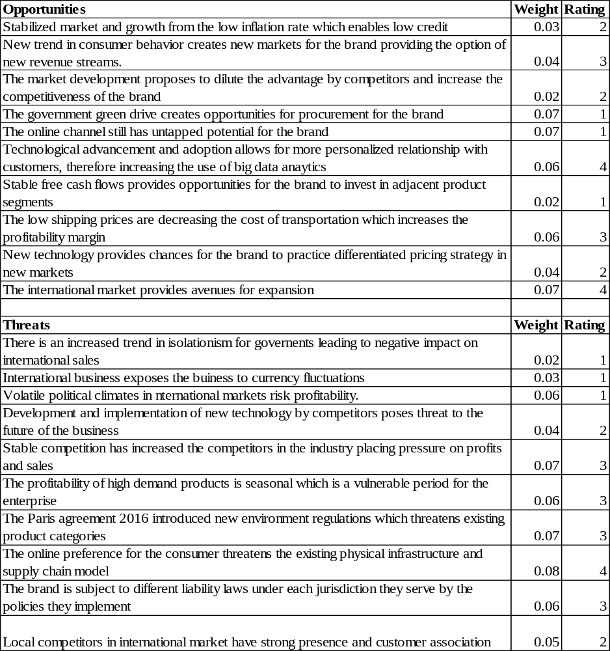
Measurement and Control System
- Current Financial Position
Dunkin Brand
Income statement overview
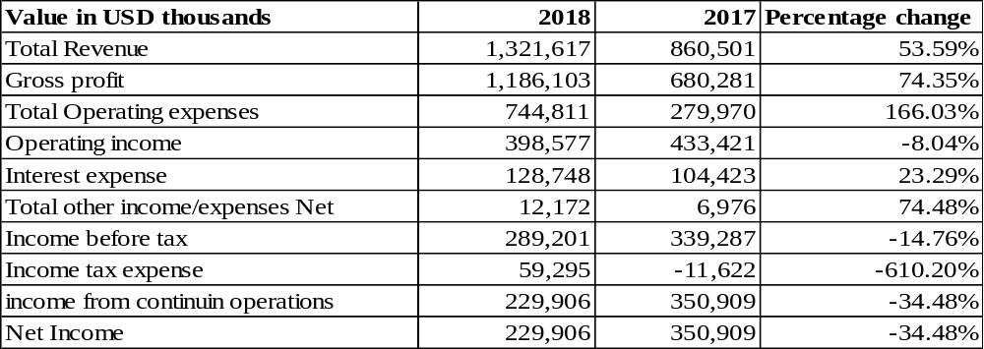
Balance sheet
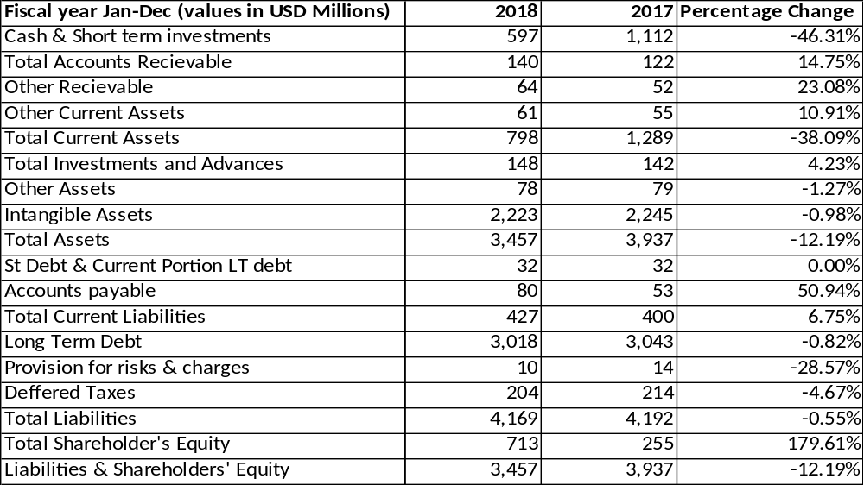
- Competitor Analysis
Starbuck Corporation
Income statement
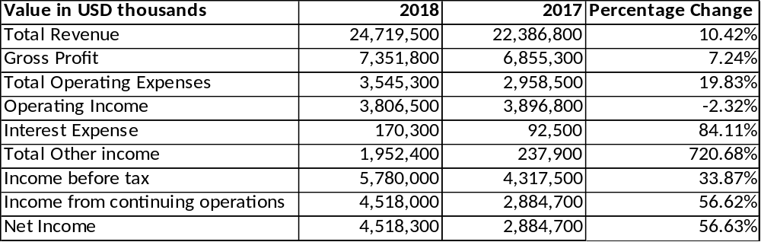
Balance Sheet
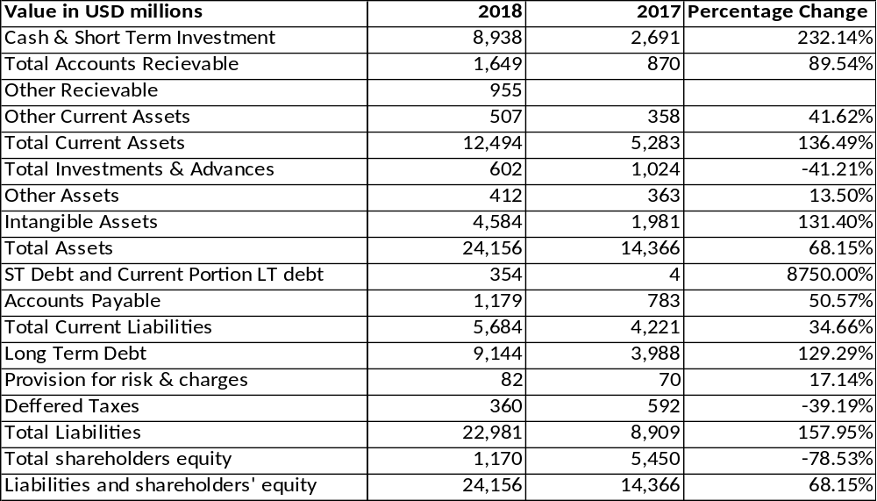
- Key Performance Indicators (KPI’s)
Dunkin’ Brands use retail and lead factions to assess the KPI in web analytics. On the retail section, evaluation takes account of the purchases of products from their websites, and also uses analytics of the number of viewers. Assessment also follows the conversion rates to acknowledge the number of clientele who fill out their reward programs online. The initiatives intends at growing awareness of the brand, and engagement of consumers. The brand also evaluates the revenue from their online presence as a measure of the efficiency and effectiveness of the platform. The corporation also earns royalty revenues from franchisee fees, which earn more within the United States than on the international scene. Rental income is another KPI indicator for the franchise.
Analysis of the Organization
- Mission Statement
Dunkin’s mission statement is also given on the corporate website, but it is titled “Our Priorities.” The statement has four parts: Our People, Our Guests, Our Neighborhoods, and Our Planet. Regarding out people, the brand declares that “From our employees and franchises to the farmers who grow our coffee, we believe in treating everyone with respect and fairness so that they are empowered to reach their goals.” On the context of guests, the statement reads “We are passionate about offering our guests delicious products they will enjoy, giving them plenty of menu options, and providing accurate nutrition information so they can make the best choices for themselves.” The promise to the neighborhoods is, “We are dedicated to serving the basic needs of our local communities – from providing food for the hungry and support for children’s health and wellness, to ensuring our neighborhoods are safe and secure.” The mission priority regarding our planet states “We recognize that everything we do has an impact on the environment. From the materials we use, to the way we construct and operate out stores, we are committed to adopting better, more sustainable approaches whenever possible.”
- Vision Statement
Dunkin’s vision statement is given on the corporate website as follows: “Serving Responsibly—To be recognized as a company that responsibly serves our guests, franchisees, employees, communities, business partners, and the interests of our planet.”
- Core values and Operating Guidelines
Dunkin’ Brand core values are honesty, transparency, humility, integrity, respectfulness, fairness, and responsibility. The guiding principles for the brand are leadership, innovation, execution, stewardship, and fun. However, there is lack of association of the brand with responsible management for their corporate green initiative which is opposite to their core values. The enterprise also does not comply with the standards of stewardship since the risks posed with high sugars and the high probability of obesity for their target population makes their menus a sign of corporate green over value. The solution to this challenge has been to remove the donuts title from the brand which has had significant negative impact for the company in critical marketable locations.
- Uniqueness of core competencies in the industry
One critical core competency of the Dunkin’ Brand is customer loyalty. The company restates the same when they declare the love from the consumer to the franchise, and expounds by making it a central component towards competitiveness and strategy. The aspect is not unique since very company in the industry targets at implementing protocols that hold knowledge and people with almost as high significance as capital and assets. Another integral competency is the model of coffee-first which the corporation aims will lead to consistent quality with low costs. However, the same model is already in place with various competitors in the quick service restaurant market. Many competitors have a tight grip on the supply chain of their respective brands. However, Dunkin’ has managed the same with minimal inventory giving them an edge in quality, consistency, and availability.
- SMART approach to the goals of the organization
- Dunkin’ Brands has a goal that seeks to increase the awareness of the brand
- First objective is the development of an application
- Tactics involves including pre-pay and pre-order services into the protocols
- Provide platform for where clients can openly share opinions and give rating
- The brand also seeks secondary avenues for marketing
- One such avenues is the sponsorship of the Spartan race
- Provide complimentary products at the finish line of the race
- Provide additional benefits to clients
- Engage the clients with activities and provide coupons
- Track how the clients use the coupons they win
- The Dunkin Brand also seeks to increase the sales
- Aligning the prices of products with the environment
- Provision of products that meet the income ratio of residents
- Assess the adaptability of the menu with consideration for the social classes
- Capitalize on social media and mobile marketing
- Make use of the cookies to gain a better understanding of the clientele
- Increase the level of engagement of existing and probable consumers
- Engage in and promote local activities within location of business
- Altruistic intentions to improve the community
- Involve the locals in strategy formulation
- Attraction of new clientele into the fold
- Dunkin Brand seeks to attract health conscious customers
- Provide products with healthy options
- Advertise awareness of the new product to existing and new markets
- Capitalist view of the consumers looking for healthy alternatives
- Assess how much the clients are willing to pay for healthy options
- Seek professional nutritional consult in a differentiated menu
- Use big data analytics for consumer survey
- Create a data set for the targeted population of clients.
- Implement statistics to create service customized for the group
Future of the Organization
The brand has actively demonstrated their strategy for development with targets set to open between 200-250 new restaurants within the United States annually over the course of the next three years. The strategy has focused more than 90% of the target locations in the North East. The strategy incorporates a modern design setting for the new and existing franchisees (Dunkin' Brands, 2019). The medications detailed under the new development will incorporate and capitalize on new strategies such as on-the go mobile ordering, high quality drive-through, and on-tap cold beverages just to highlight a few. The brand also targets the retail market through exploiting their formats to include universities, travel plazas, gas and convenience stores, in-line sites, end caps, and free standing restaurants. The restaurants will exploit the use of technology to make their establishments innovative in the hope of staying relevant to its customers.
Conclusion
The Dunkin’ Brand has rejuvenated its portfolio since the dropping of the term Donuts in its branding. The barriers in the industry have influenced innovation from the brand and its competitors with incorporation of new and emerging technology into its structure. The business model of the organization serves to increase the expansive reach of the brand even if the home state brings in more profit than the international market. The business model also incorporates a franchising fee that is integral to the long standing stature of the organization. Future scenario will exploit other retail business venture with keen intent to be associated with the brand, or who seek to capitalize on the premium location for the brand. The organization also strategizes at acquiring and maintaining a competitive edge through continued innovation.

Sources
Celentano, D. (2019, February 2). What Leads Food Startup to Fail. Retrieved October 17, 2019, from The Balance: Small Business: https://www.thebalancesmb.com/avoid-these-5-major-problems-of-food-startups-1326075
Dombroski, S. (2018, February 23). How to mange food & Bverage quality regulations with a food management safety system. Retrieved October 17, 2019, from Manufcturing.Net: https://www.manufacturing.net/article/2018/02/how-manage-food-beverage-quality-regulations-food-management-safety-system
Dunkin' Brands. (2019, May 8). Dunkin' Kicks-Off Strong Year With 50 New Locations Planned For Development Under Newly Signed Store Development Agreements. Retrieved 2019, from Ciston News Wire: https://www.prnewswire.com/news-releases/dunkin-kicks-off-strong-year-with-50-new-locations-planned-for-development-under-newly-signed-store-development-agreements-300845884.html
Dunkin's Brands Group, Inc. Porter Five Forces Analysis. (n.d.). Retrieved October 17, 2019, from Fern Fort University: http://fernfortuniversity.com/term-papers/porter5/analysis/2734-dunkin--brands-group--inc-.php
Hood, K. (n.d.). Why are most food and drinks businesses failing?
Insight Article. (2019, january 7). Top 2019 trends for food and beverage industry businesses. Retrieved October 17, 2019, from RSMUS: https://rsmus.com/what-we-do/industries/consumer-products/food-and-beverage/top-trends-for-food-and-beverage-industry-businesses.html
Jones, A. (n.d.). Dunkin' Brands' strategic focus and supply chain. Retrieved from Market Realist.
LaMarco, N. (2019, March 29). Political problem affecting the restaurant industry. Retrieved October 17, 2019, from Market Research: BizFluent: https://bizfluent.com/13345231/political-problems-affecting-the-restaurant-industry
Neil, S. (2019). The future of the food and beverage industry. Retrieved October 17, 2019, from Pro Food World: https://www.profoodworld.com/articles/future-food-and-beverage-industry
The Official Board. (n.d.). Dunkin' Brands. Retrieved October 17, 2019, from The Official Board: https://www.theofficialboard.com/org-chart/dunkin-brands
The Wall Street Journal. (2019, October 17). Starbucks Corp. Retrieved October 17, 2019, from The Wall Street Journal: https://quotes.wsj.com/SBUX/financials/annual/balance-sheet
Woods, L. (2017, September 26). Types of economic factors that can affect the fast food industry. Retrieved October 17, 2019, from BizFluent: https://bizfluent.com/info-12320022-types-economic-factors-can-affect-fast-food-industry.html
Yahoo Finance. (2019, October 17). Dunkin' Brands Group, Inc. (DNKN). Retrieved October 17, 2019, from Yahoo Finance: https://finance.yahoo.com/quote/DNKN/financials?p=DNKN

